Name__________________________ Period_____________________

Review Linear Functions

Find the slope and y-intercept and graph

1. 2.
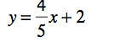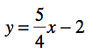

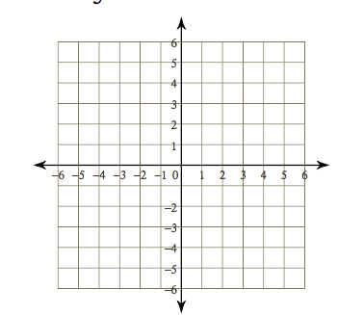

3. 4.
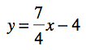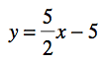
5. 6.
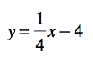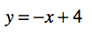

7. 8.
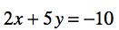

9. 10.
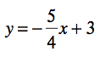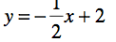

11. 12.
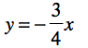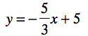

Write the slope-intercept form of the equations.

13. 14.
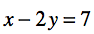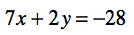

15. 16.
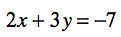

17. 18.
