Evolutionary Theory (and Theorists)
What is Evolution?

Erasmus Darwin

Lamarck

Cuvier vs. Hutton

Charles Lyell

Thomas Malthus

Alfred Russel Wallace

Charles Darwin

QUESTIONS:
1. Evolution can be defined as “change through time”. What is changing?
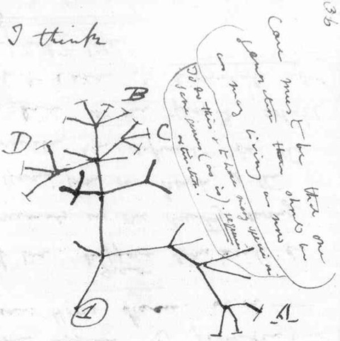
2. What was Darwin trying to say in this sketch from his journal?

3. What is meant by his phrase “descent with modification”?

4. Based on the ideas of biogeography, predict whether a fossil of an extinct mammal that lived high in the Andes would be more closely related to a present-day mammal that lives in South American jungles or a present day mammal that lives in high in the mountains of Africa.

5. Match the description with the correct term.
A. Catastrophism B. Gradualism C. Uniformitarianism
______ History of Earth marked by floods or droughts that resulted in extinction
______ Profound change is the cumulative product of slow but continuous processes
______ Geological forces at work today are the same forces that shaped the Earth in the past

6. How did the work of James Hutton and Charles Lyell influence the work of Charles Darwin?

7. Lamarck proposed a mechanism to explain how specific adaptations evolved. This mechanism incorporated the ideas of use & disuse and acquired traits.
Idea | Explanation
Use and Disuse
Acquired Traits

8. Consider the giraffe’s long neck. Explain how this came about using Lamarck’s concept of evolution (inheritance of acquired traits.)

9. Very recent work in epigenetics is reviving Lamarckism in a very specific and limited way. Genes cannot be changed or altered by our experiences, but the expression of genes can be altered by our environments/experiences (or our parents and even grandparents environments.) Explain what you remember about epigenetics and how that could in part fit with Lamarckian thought.

10. The embryologist Charles H. Waddington treated fly larvae with heat shock. As a result of this treatment, some of the adult flies showed the abnormal condition “crossveinless” (some of their wing veins were missing.) After several generations of this treatment, he let a generation of flies develop without heat treatment and many of them were also crossveinless. Does this experiment provide convincing proof of Lamarckism? If not, what other explanation can you suggest, and what experiments would you perform to test your suggestions?

11. Consider the giraffe’s long neck. Explain how this came about using Darwin’s mechanism of evolution (natural selection.)

12. From his observations of organisms in the Galapagos islands, Darwin reasoned that...
a. the organisms in the Galapagos had been specially created to thrive in that environment
b. all island species should be similar to each other
c. the shape of a bird's beak does not affect its ability to survive and reproduce
d. organisms had adapted to new environments, giving rise to new species

13. Why is there a constant struggle for survival among organisms within a population?

14. What is (are) the difference(s) between natural selection and adaptation?

15. Given a population that contains genetic variation, what is the correct sequence of the following events, under the influence of natural selection?
1. Well-adapted individuals leave more offspring than do poorly adapted individuals.
2. A change occurs in the environment.
3. Genetic frequencies within the population change.
4. Poorly adapted individuals have decreased survivorship.
a. 4, 2, 3, 1
b. 2, 4, 1, 3
c. 4, 2, 1, 3
d. 2, 4, 3, 1
e. 4, 1, 2, 3

16. An individual acquires many traits during its lifetime. (For example, right now I hope you are getting more knowledgeable about biology and your coaches hope you are getting stronger or faster or more skilled.) How important are these acquired characteristics to evolution? Explain.

17. Define the term population.

18. Explain why populations, and not individuals evolve. (This is really important)

19. In a hypothetical environment, fishes called pike-cichlids are visual predators of algae-eating fish (in other words, they locate their prey by sight). If a population of algae-eaters experiences predation pressure from pike-cichlids, which of the following is least likely to be observed in the algae-eater population over the course of many generations?
a. selection for nocturnal algae-eaters (active only at night)
b. selection for larger female algae-eaters, bearing broods composed of more, and larger, young
c. selection for drab coloration of the algae-eaters
d. selection for algae-eaters that become sexually mature at smaller overall body sizes

20. Explain how each of the following provide evidence in support of Darwin’s understanding of how evolution worked.
CATEGORY | What makes sense to you about how it supports evolutionary theory?
Biogeography
Fossil record
Comparative anatomy
Comparative Embryology
Molecular Biology

21. Define and give examples of each of the following.
STRUCTURE | DEFINITION | EXAMPLES
Homologous
Vestigial

