Name:____________________

Forensic Science
Study Guide #15 – Firearms, Tool Marks, and Other Impressions
3.19.18

(Note: This study guide is worth 150 points because it’s super-duper stinkin’ long and I want to reward you for your effort. Due Friday, March 23rd.)

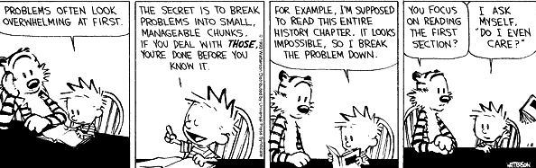

- In the case of the Beltway Snipers, what was the first hint that led police to John Allen Muhammad?
- Same question that I always ask, different topic – are firearms and tool marks generally considered to be class or individual evidence?
- What is the choke of a shotgun, and what is its purpose?
- Describe the difference between lands and grooves.
- What is the purpose of the grooves on the inside of a gun barrel?
- What shoots a larger diameter bullet – a .30 caliber rifle or a 9mm handgun? Hint: You’ll need to grab a ruler for this one.
- How might a forensic investigator tell whether a .32 caliber bullet was fired from a Smith and Wesson revolver or a Colt revolver?
- If all the firearms made by the same company are rifled in the same way, why is it that each barrel has individual characteristics? Explain.
- What are two reasons that bullets fired from the same firearm might not give an investigator a perfect match?
- Can pellets fired from a shotgun be traced back to a single weapon? Explain.
- Which is a larger shotgun, a 10 gauge or a 20 gauge? Explain.
- If a bullet is not recovered from a crime but spent shell casings are, the investigator still may have up to four markings that can be individualized. Define or explain the significance of the following four terms:
  - Firing pin
  - Breechblock
  - Extractor
  - Ejector
- What evidence might an investigator look for if a murder suspect claimed that he killed a person in self-defense? Explain.
- What bits of evidence (or lack thereof) might lead an investigator to determine that a shot was likely fired at the following distances: (2 pts)
  - Contact up to 1”
  - < 12”
  - < 25”
  - < 3’
- In very general terms, how can an investigator tell if someone has fired a gun recently, apart from giving them a lie-detector (polygraph) test?
- When collecting a revolver as evidence, why would the cylinder position be important to note? How might that help investigators in their prosecution of the case?
- Criminals often throw their firearms into rivers or lakes after they’re used in a crime. If you find such a weapon while investigating a crime, what is the proper way to store and transport this firearm evidence? Why?
- If I found a bullet stuck in the wall, why would it be a very bad idea to remove it from the wall with a pair of tweezers if I wanted it as evidence?
- While tool marks generally cannot be individualized to a specific tool, at times they can be. What characteristics of a tool might enable investigators to link it to a tool mark left at a crime scene?

Note: Take a look at Fig. 15-27. When we lift footprints and tire tracks in the coming weeks, that is darn near exactly what I expect from you as far as a detailed analysis.

- What sorts of features must an investigator look for if she is to consider a footwear impression as individual evidence?
- Back to O.J. Simpson – why were the prints left at the scene of the murders of Nicole Brown and Ronald Goldman so difficult for an expert to match to their source?
- Answer question #2 of the Application and Critical Thinking section.
- Answer question #4 of the Application and Critical Thinking section.

